**N4AIAO4 modbus rtu protocol**

**Function code**

|  |  |  |  |  |
| --- | --- | --- | --- | --- |
| RS485 address  (Station address)  (1) | Function (1) | Register address (2) | Read number (2) | CRC16 (2) |
|  | 03 Read |  |  |  |
|  | 06 Write |  |  |  |

|  |  |  |  |  |
| --- | --- | --- | --- | --- |
| Read-only register,Read Function code Is 03 | | | | |
| Register address | Register contents | Number of bytes | Units | Remarks |
| 0x0000 | (CH1)V1 voltage value | 2 | 0.01V | such as:  Get 0x014A  Decimal 330  Voltage = 330 * 0.01 = 3.3V |
| 0x0001 | (CH2)V2 voltage value |
| 0x0002 | (CH3)C1 Current value | 2 | 0.1MA | such as:  Get 0x00C8  Decimal 200  Current= 2000 * 0.1 = 20MA |
| 0x0003 | (CH4)C2 Current value |
| Read / write register; Read function code is 03 ,Write function code is 06 | | | | |
| 0x0007 | (CH1)V1 voltage ratio | 2 | 0.1%  millesimal | This value can be corrected when the voltage/Current reading deviation is greater than 1%, such as:  1000 means 1:1  1010: 1% increase  990: 1% decrease |
| 0x0008 | (CH2)V2 voltage ratio |
| 0x0009 | (CH3)C1 Current ratio |
| 0x000A | (CH4)C2 Current ratio |
| 0x000E | RS485 address  (Station address) | 2 |  | Read Address 0XFF  Write Address 1-247 |
| 0x000F | Baud rate | 2 |  | 0~4 0:1200  1:2400 2:4800  3:9600（default）  4:19200  5: Factory reset |

**Serial baud rate：9600（**default**），N，8，1**

**Modbus RTU Communication protocol：**

1. **Read Voltage/Current value**

Send data

|  |  |  |  |  |
| --- | --- | --- | --- | --- |
| RS485 address  (Station address)  (1) | Function (1) | Register address (2) | Read number (2) | CRC16(2) |

Returns data

|  |  |  |  |  |
| --- | --- | --- | --- | --- |
| RS485 address  (Station address)  (1) | Function (1) | Number of bytes (1) | data (n) | CRC16(2) |

RS485 address(Slave ID) : 0x01~0xFE

Function code 0x03

Register address：0x0000-0x0003, Indicates 1-4 channel value

Read number：0x0001-0x0004

**Read Voltage:**

The return of the Voltage value is two bytes，High-bit in the former and low-bit in the post,convert it to decimal and divided by 100, is the Voltage value, Unit 0.01V; for example:

For example:

Send data(RS485 address is 1)：01 03 00 00 00 01 84 0A

Returns data：01 03 02 01 4B F9 E3

01 RS485 address，03 Function，02 length，F8 E3 crc16

014B is the Voltage value, it is converted to decimal = 331, 331/100=3.31V；

Returns data：01 03 02 00 DB F8 1F

00DB is the Voltage value, it is converted to decimal =219, 219/100=2.19V；

**Read Current:**

The return of the Current value is two bytes，High-bit in the former and low-bit in the post,convert it to decimal and divided by 10, is the Current value, Unit 0.1MA; for example:

For example:

Send data(RS485 address is 1)：01 03 00 02 00 01 25 CA

Returns data：01 03 02 00 78 B8 66

01 RS485 address，03 Function，02 length，B8 66 crc16

0078 is the Current value, it is converted to decimal = 120, 1200/10=12MA；

1. **Read RS485 address**

Send data

|  |  |  |  |  |
| --- | --- | --- | --- | --- |
| RS485 address  (Broadcast address)  (1) | Function (1) | Register address (2) | Read number (2) | CRC16(2) |

Returns data

|  |  |  |  |  |
| --- | --- | --- | --- | --- |
| RS485 address  ( Broadcast address )  (1) | Function (1) | Number of bytes (1) | data (n) | CRC16(2) |

Broadcast address 0xff

Function code 0x03

Register address：0x000E

Read number：0x0001

For example:

send data：FF 03 00 0E 00 01 F0 17

Returns data：FF 03 02 00 01 50 50

FF Broadcast address，03 Function，02 length，01 is the current module RS485 address , 50 50 crc16

Note: When using this command, only one temperature module can be connected to the RS485 bus, more than one will be wrong!

1. **Write RS485 address**

Send data

|  |  |  |  |  |
| --- | --- | --- | --- | --- |
| RS485 address  (Station address)  (1) | Function (1) | Register address (2) | Setting Content (2) | CRC16(2) |

Returns data

|  |  |  |  |  |
| --- | --- | --- | --- | --- |
| RS485 address  (Station address)  (1) | Function (1) | Register address  (2) | Register value (2) | CRC16(2) |

RS485 address(Slave ID) : 0x01~0xFE

Function code 0x06

Register address：0x000E

Setting Content：2Bytes(1-247)

For example, The current RS485 address is 1, We need to change the RS485 address to 3:

send data(RS485 address is 1)：01 06 00 0E 00 03 A8 08

Returns data：01 06 00 0E 00 03 A8 08

1. **Read baud rate**

Send data

|  |  |  |  |  |
| --- | --- | --- | --- | --- |
| RS485 address  (Station address)  (1) | Function (1) | Register address (2) | Read number (2) | CRC16(2) |

Returns data

|  |  |  |  |  |
| --- | --- | --- | --- | --- |
| RS485 address  (Station address)  (1) | Function (1) | Number of bytes (1) | data (n) | CRC16(2) |

RS485 address(Slave ID) : 0x01~0xFE

Function code 0x03

Register address：0x000F

Read number：0x0001

For example:

send data(RS485 address is 1)：01 03 00 03 00 01 74 0A

Returns data：01 03 02 00 03 F8 45

01 RS485 address，03 Function，02 length，F8 45 crc16

03 means the current baud rate is 9600bps

Baud rate corresponds to the number: 0: 1200 1: 2400 2: 4800 3: 9600 4: 19200

1. **Write baud rate**

Send data

|  |  |  |  |  |
| --- | --- | --- | --- | --- |
| RS485 address  (Station address)  (1) | Function (1) | Register address (2) | Setting Content (2) | CRC16(2) |

Returns data

|  |  |  |  |  |
| --- | --- | --- | --- | --- |
| RS485 address  (Station address)  (1) | Function (1) | Register address  (2) | Register value (2) | CRC16(2) |

RS485 address(Slave ID) : 0x01~0xFE

Function code 0x06

Register address：0x000F

Setting Content：2Bytes(0-4)

For example, Change the baud rate to 4800bps:

send data(RS485 address is 1)：01 06 00 0F 00 02 38 08

Returns data：01 06 00 0F 00 02 38 08

Baud rate corresponds to the number: 0: 1200 1: 2400 2: 4800 3: 9600 4: 19200

5: Factory reset

Note: 1 The baud rate will be updated when the module is powered up again!

2 The factory setting can be restored when the baud rate corresponding to the number is 5. For example: 01 06 00 0F 00 05 79 CA

1. **Read voltage/current ratio:**

Send data

|  |  |  |  |  |
| --- | --- | --- | --- | --- |
| RS485 address  (Station address)  (1) | Function (1) | Register address (2) | Read number (2) | CRC16(2) |

Returns data

|  |  |  |  |  |
| --- | --- | --- | --- | --- |
| RS485 address  (Station address)  (1) | Function (1) | Number of bytes (1) | data (n) | CRC16(2) |

RS485 address(Slave ID) : 0x01~0xFE

Function code 0x03

Register address：0x0007-0x000A ; Indicates 1-4 channel value

Read number：0x0001-0x0004

Return data: 0.1% millesimal

The voltage ratio can be corrected by this value when the voltage reading deviation is greater than 1%. The default value is 1000 (3E8).

For example 1:

send data(RS485 address is 1)：01 03 00 07 00 01 35 CB; 07 is Channel 1

Returns data：01 03 02 03 E8 B8 FA

03E8 is the voltage ratio, which is 1000 in decimal and divided by 1000=1; indicating that channel 1 does not need to modify the voltage value.

For example 2:

send data(RS485 address is 1)：01 03 00 08 00 01 05 C8; 08 is Channel 2

Returns data：01 03 02 03 DE 38 EC

03DE is the voltage ratio, which is 990 in decimal and divided by 1000=0.99; Indicates that channel 2 reads 0.99 times the actual acquisition value.

1. **Set voltage ratio**

The voltage ratio can be corrected by this value when the voltage reading deviation is greater than 1%. The default value is 1000 (3E8).

Send data

|  |  |  |  |  |
| --- | --- | --- | --- | --- |
| RS485 address  (Station address)  (1) | Function (1) | Register address (2) | Setting Content (2) | CRC16(2) |

Returns data

|  |  |  |  |  |
| --- | --- | --- | --- | --- |
| RS485 address  (Station address)  (1) | Function (1) | Register address  (2) | Register value (2) | CRC16(2) |

RS485 address(Slave ID) : 0x01~0xFE

Function code 0x06

Register address：0x0007-0x000D ; Indicates 1-7 channel value

Setting Content：2Bytes

Setting value: 2 bytes, unit 0.1%. When this value is set to 1000 (3E8), the voltage value does not change.

For example 1: The actual voltage of channel 1 is 5.00V, but the read value is only 4.00V. The ratio deviation is 5/4=1.25, and the correction voltage ratio is changed to 1250, which can correct the voltage.

Send frame: 01 06 00 07 04 E2 BA 82

Return frame: 01 06 00 07 04 E2 BA 82

The return frame is the same as the send frame. 07 means channel 1, 04 E2 means correction voltage ratio is 1250

For example 2: The actual voltage of channel 1 is 4.00V, but the read value is only 5.00V. The ratio deviation is 4/5=0.8, and the correction voltage ratio is changed to 800, which can correct the voltage.

Send frame: 01 06 00 08 03 20 09 20

Return frame: 01 06 00 08 03 20 09 20

The return frame is the same as the send frame. 08 means channel 2, 03 20 means correction voltage ratio is 800

MODBUS commands you can use "Modbus Poll" input, as shown below

（CRC check generated automatically）

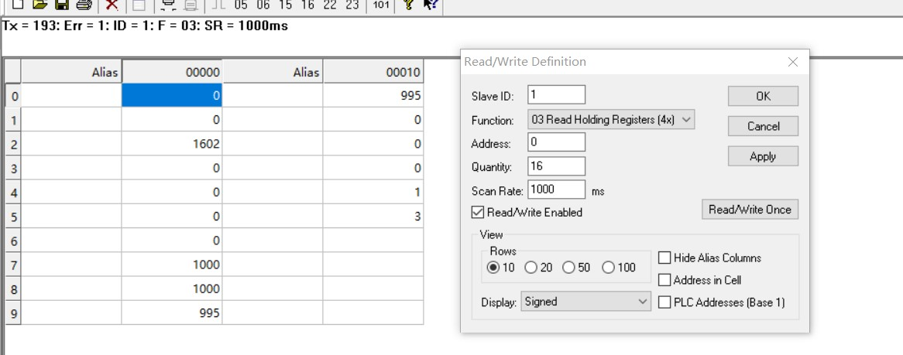

You can also use HyperTerminal serial input, as shown below

（Manually add CRC check）

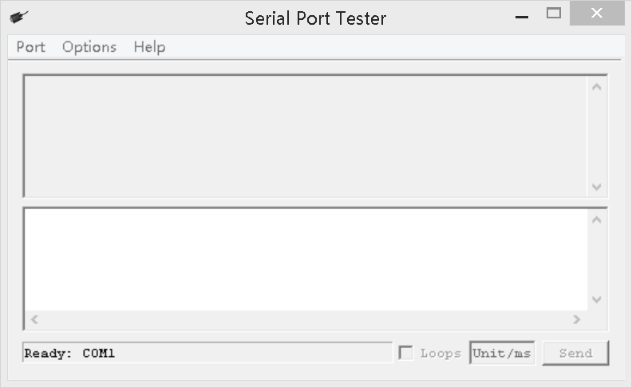

**CRC check code(C51 MCU)：**

const unsigned char code auchCRCHi[256] = {

0x00, 0xC1, 0x81, 0x40, 0x01, 0xC0, 0x80, 0x41, 0x01, 0xC0, 0x80, 0x41, 0x00, 0xC1, 0x81, 0x40,

0x01, 0xC0, 0x80, 0x41, 0x00, 0xC1, 0x81, 0x40, 0x00, 0xC1, 0x81, 0x40, 0x01, 0xC0, 0x80, 0x41,

0x01, 0xC0, 0x80, 0x41, 0x00, 0xC1, 0x81, 0x40, 0x00, 0xC1, 0x81, 0x40, 0x01, 0xC0, 0x80, 0x41,

0x00, 0xC1, 0x81, 0x40, 0x01, 0xC0, 0x80, 0x41, 0x01, 0xC0, 0x80, 0x41, 0x00, 0xC1, 0x81, 0x40,

0x01, 0xC0, 0x80, 0x41, 0x00, 0xC1, 0x81, 0x40, 0x00, 0xC1, 0x81, 0x40, 0x01, 0xC0, 0x80, 0x41,

0x00, 0xC1, 0x81, 0x40, 0x01, 0xC0, 0x80, 0x41, 0x01, 0xC0, 0x80, 0x41, 0x00, 0xC1, 0x81, 0x40,

0x00, 0xC1, 0x81, 0x40, 0x01, 0xC0, 0x80, 0x41, 0x01, 0xC0, 0x80, 0x41, 0x00, 0xC1, 0x81, 0x40,

0x01, 0xC0, 0x80, 0x41, 0x00, 0xC1, 0x81, 0x40, 0x00, 0xC1, 0x81, 0x40, 0x01, 0xC0, 0x80, 0x41,

0x01, 0xC0, 0x80, 0x41, 0x00, 0xC1, 0x81, 0x40, 0x00, 0xC1, 0x81, 0x40, 0x01, 0xC0, 0x80, 0x41,

0x00, 0xC1, 0x81, 0x40, 0x01, 0xC0, 0x80, 0x41, 0x01, 0xC0, 0x80, 0x41, 0x00, 0xC1, 0x81, 0x40,

0x00, 0xC1, 0x81, 0x40, 0x01, 0xC0, 0x80, 0x41, 0x01, 0xC0, 0x80, 0x41, 0x00, 0xC1, 0x81, 0x40,

0x01, 0xC0, 0x80, 0x41, 0x00, 0xC1, 0x81, 0x40, 0x00, 0xC1, 0x81, 0x40, 0x01, 0xC0, 0x80, 0x41,

0x00, 0xC1, 0x81, 0x40, 0x01, 0xC0, 0x80, 0x41, 0x01, 0xC0, 0x80, 0x41, 0x00, 0xC1, 0x81, 0x40,

0x01, 0xC0, 0x80, 0x41, 0x00, 0xC1, 0x81, 0x40, 0x00, 0xC1, 0x81, 0x40, 0x01, 0xC0, 0x80, 0x41,

0x01, 0xC0, 0x80, 0x41, 0x00, 0xC1, 0x81, 0x40, 0x00, 0xC1, 0x81, 0x40, 0x01, 0xC0, 0x80, 0x41,

0x00, 0xC1, 0x81, 0x40, 0x01, 0xC0, 0x80, 0x41, 0x01, 0xC0, 0x80, 0x41, 0x00, 0xC1, 0x81, 0x40

} ;

const unsigned char code auchCRCLo[256] = {

0x00, 0xC0, 0xC1, 0x01, 0xC3, 0x03, 0x02, 0xC2, 0xC6, 0x06, 0x07, 0xC7, 0x05, 0xC5, 0xC4,0x04,

0xCC, 0x0C, 0x0D, 0xCD, 0x0F, 0xCF, 0xCE, 0x0E, 0x0A, 0xCA, 0xCB, 0x0B, 0xC9, 0x09, 0x08, 0xC8,

0xD8, 0x18, 0x19, 0xD9, 0x1B, 0xDB, 0xDA, 0x1A, 0x1E, 0xDE, 0xDF, 0x1F, 0xDD, 0x1D, 0x1C, 0xDC,

0x14, 0xD4, 0xD5, 0x15, 0xD7, 0x17, 0x16, 0xD6, 0xD2, 0x12, 0x13, 0xD3, 0x11, 0xD1, 0xD0, 0x10,

0xF0, 0x30, 0x31, 0xF1, 0x33, 0xF3, 0xF2, 0x32, 0x36, 0xF6, 0xF7, 0x37, 0xF5, 0x35, 0x34, 0xF4,

0x3C, 0xFC, 0xFD, 0x3D, 0xFF, 0x3F, 0x3E, 0xFE, 0xFA, 0x3A, 0x3B, 0xFB, 0x39, 0xF9, 0xF8, 0x38,

0x28, 0xE8, 0xE9, 0x29, 0xEB, 0x2B, 0x2A, 0xEA, 0xEE, 0x2E, 0x2F, 0xEF, 0x2D, 0xED, 0xEC, 0x2C,

0xE4, 0x24, 0x25, 0xE5, 0x27, 0xE7, 0xE6, 0x26, 0x22, 0xE2, 0xE3, 0x23, 0xE1, 0x21, 0x20, 0xE0,

0xA0, 0x60, 0x61, 0xA1, 0x63, 0xA3, 0xA2, 0x62, 0x66, 0xA6, 0xA7, 0x67, 0xA5, 0x65, 0x64, 0xA4,

0x6C, 0xAC, 0xAD, 0x6D, 0xAF, 0x6F, 0x6E, 0xAE, 0xAA, 0x6A, 0x6B, 0xAB, 0x69, 0xA9, 0xA8, 0x68,

0x78, 0xB8, 0xB9, 0x79, 0xBB, 0x7B, 0x7A, 0xBA, 0xBE, 0x7E, 0x7F, 0xBF, 0x7D, 0xBD, 0xBC, 0x7C,

0xB4, 0x74, 0x75, 0xB5, 0x77, 0xB7, 0xB6, 0x76, 0x72, 0xB2, 0xB3, 0x73, 0xB1, 0x71, 0x70, 0xB0,

0x50, 0x90, 0x91, 0x51, 0x93, 0x53, 0x52, 0x92, 0x96, 0x56, 0x57, 0x97, 0x55, 0x95, 0x94, 0x54,

0x9C, 0x5C, 0x5D, 0x9D, 0x5F, 0x9F, 0x9E, 0x5E, 0x5A, 0x9A, 0x9B, 0x5B, 0x99, 0x59, 0x58, 0x98,

0x88, 0x48, 0x49, 0x89, 0x4B, 0x8B, 0x8A, 0x4A, 0x4E, 0x8E, 0x8F, 0x4F, 0x8D, 0x4D, 0x4C, 0x8C,

0x44, 0x84, 0x85, 0x45, 0x87, 0x47, 0x46, 0x86, 0x82, 0x42, 0x43, 0x83, 0x41, 0x81, 0x80,0x40

} ;

unsigned int CRC_16(unsigned char *str,unsigned int usDataLen)

{

unsigned char uchCRCHi = 0xFF ; /* high byte of CRC initialized */

unsigned char uchCRCLo = 0xFF ; /* low byte of CRC initialized */

unsigned uIndex ; /* will index into CRC lookup table */

while (usDataLen--)/* pass through message buffer */

{

uIndex = uchCRCHi ^ *str++ ; /* calculate the CRC */

uchCRCHi = uchCRCLo ^ auchCRCHi[uIndex];

uchCRCLo = auchCRCLo[uIndex] ;

}

return (uchCRCHi << 8 | uchCRCLo) ;

}